20.08.2014

FILMTERACTIVE: Is social production a new way for a documentary film?
Sundog Pictures Studio in cooperation with Google used YouTube for the realization and distribution of their documentary film about drug wars. Is Breaking the Taboo a proof traditional full-time documentary film is not enough in the XXI century?

The value of YouTube content is often underestimated because of cute pets films or virals of Harlem Shake type. It's worth looking at YouTube as a priceless and almost infinite source of documentary films.

Ridley Scott's and Kevin Macdonald's Life in a day is a mile stone for the genre. The production from 2011, based on crowd-sourcing is a material obtained out of 80.000 videos from YouTube users. To contribute to this document, they sent their own documentary films on how they had spent particular days of the year. Life in a day has more than 35 million views and its main production idea was copied by BBC for the Olympic Games in London as well as by Japanese Fuji Television for the commemoration of 2011 catastrophe.

Kony 2012 is a 30 minutes production encouraging to catch the African refugee police leader, Joseph Kony. The production has been supported by such celebrities as Oprah Winfrey, George Clooney and Angelina Jolie. The documentary film spread with a viral power and had over a billion views on YouTube.

Those productions and their social media success and the social success in more general meaning, had inspired Sundog Pictures, established by Sam Branson and Johnny Webb, ex-boss of Virgin Media TV. They decided to create a documentary film about global drug war, entitled Breaking the Taboo, to force a deeper look into global anti-drug policy. The film is narrated by Morgan Freeman. There are also many influential persons in the cast of the film i.e. ex-presidents of the USA, Bill Clinton and Jimmy Carter, who talk about their failures in the war against drugs sales. Kate Winslet, Paulo Coelho, Gael García Bernal, Bob Geldof, Richard Branson and many others also express their opinions. The making of the film took two years and its aim is to inspire drug industry legislation changes all over the world and encourage viewers to sign a petition in this case addressed to ONZ.

According to Jonathan Webb, a documentary film, either in the cinema or in TV, touches its viewers with the history it tells. But it is unable to do anything with arisen emotions. YouTube, according to the new generation film creators, gives an opportunity to directly address the viewers and show them particular actions they can undertake, a path to follow. That's why Breaking the Taboo ends with a call to action.

Jonathan Webb, Sundog Pictures producer, will be a guest to this year's Filmteractive Festival and will talk about the distribution of documentary films in the internet, on the 25th of September in Lodz Film School. Full programme of the event is available at http://filmteractive.eu/festiwal-program.php

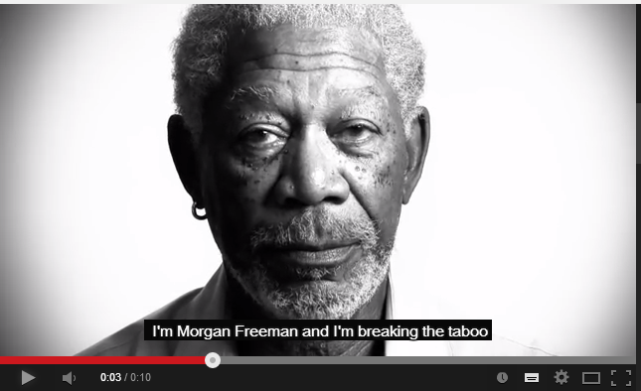
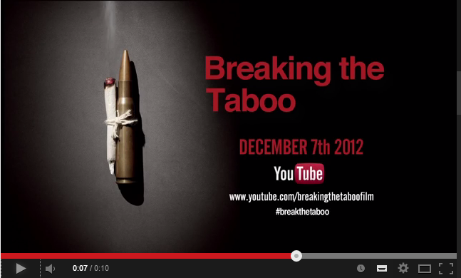
http://www.breakingthetaboo.info/
https://www.youtube.com/channel/UC1LHjFn8qGgYq_ykAVnXMAQ

