08.09.2014
Will you accept an invitation for Filmteractive?
Filmterative 2014, 24-25 September, Łódź Film School. Our focus this year is content marketing, of which these untypical invitations are informing. Does effective content marketing really fit naturally? We are going to answer this (and many more) question during The Conference. Join us!
https://www.youtube.com/watch?v=TsBbcMUgZOA&list=UUMcCH-uMuVSIT_Er5Zjo_Dg
https://www.youtube.com/watch?v=1WINXLAnV5s&list=UUMcCH-uMuVSIT_Er5Zjo_Dg

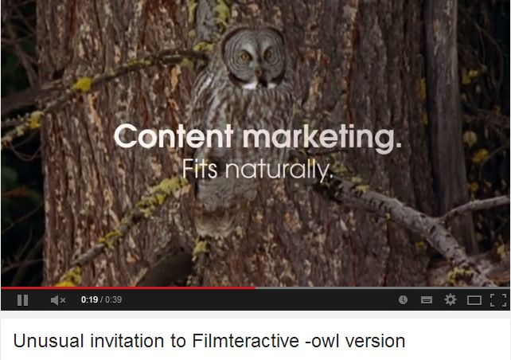
https://www.youtube.com/watch?v=e6h-HVIo4ho&feature=youtu.be
