01.10.2014

What content will knock out the world of marketing?

Is content carrying the promise of a change for better in marketing world? In what way does it influence building the bound between a user or a consumer with a brand? Why content distributed via Internet has a greater impact on its receivers than the one published in traditional media? Answers for these and many other questions could be found during this year’s Filmteractive.

Filmteractive 2014 was the fourth very special edition of this event, not only with respect to its extremely wide-ranging and engrossing programme, but also due to a significant number of invited speakers – representatives of such brands as RedBull or TVP. The main topic of the conference was content marketing – the most dominant trend of the year. Adipat Virdi, British producer of Transmediasphere, summarized the event in these words: Last year it was great, this year it’s amazing.

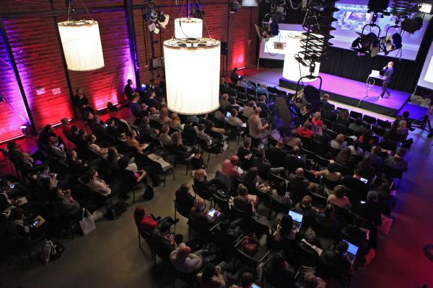

Filmteractive Conference 2014
The Conference, which took place on the first day of the event, was an opportunity to have a closer look at extraordinary marketing projects, for instance an interactive promotion of a HBO series Games of thrones, an effective distribution of Jamie Olivier programs on a dedicated food tube channel or an analysis how to create branded content 360° illustrated by the example of RedBull.
Furthermore, the Filmteractive Conference was unique occasion to attend long-awaited presentation of the report, considering the content marketing situation on the Polish market, which had been prepared specially for this occasion by Andrzej Garapich from PBI and Olgierd Cygan from Digital One.
An exceedingly significant aspect of the programme was a debate with Joe Pulizzi from Content Marketing Institute, also known as the content marketing guru.
The culmination of the day was a discussion panel on topics related to the future of online TV, in which representatives of Evio, IAB, TVP and Crowley Media took part.

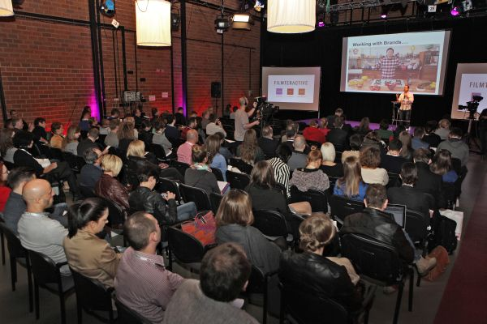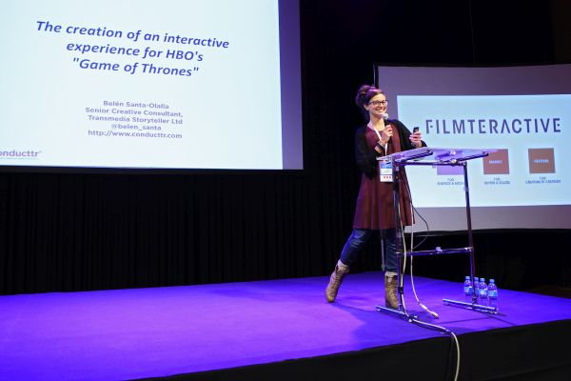

Filmteractive Festival 2014
One of the speakers of this year’s Festival was a producer Jonathan Webba, Sundog Pictures, who gave a speech on digital distribution of the documentary Breaking the Taboo. A point of the programme that was awaited especially by the guests from Poland was a lecture on copyrights and different ways of works distribution via the Internet given by a representative of ZAiKS. Moreover, a worth attending part of the event was a discussion panel hosted by Maciej Budzich, Mediafun.pl. Paulina Mikuła, Łukasz Jakóbiak, Radek Kotarski i Daniel Ciupryk deliberated over videoblogging as an alternative to traditional video distribution.
Worth mentioning aspect of the programmy on the second day of the event was also Filmteractive Market - interactive and crossmedia content marketplace and presentations of best projects submitted to the competition. The international expert panel revealed winners of the main prize - founded by EVIO Poland – and a special award, for the best project coming from the Baltic Sea Region – founded by The Northern Dimension Partnership on Culture (NDPC) - ending this edition of Filmteractive.

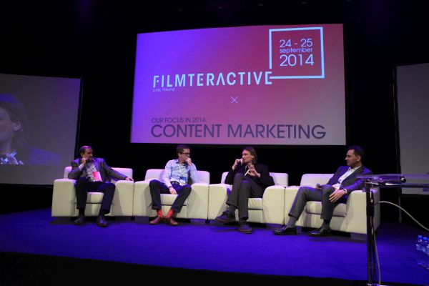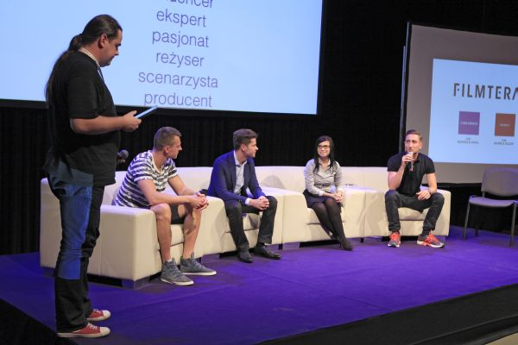

Why Filmteractive 2014 was so special?
- To this year’s conference we invited specialists in content marketing, who presented this issue from different perspectives of brands, agencies, creators and theorists - explains Agata Lepianka, Filmteractive Project Manager. – This allowed our guests to gain solid knowledge and become familiar with interesting marketing projects.

To learn more visit: http://filmteractive.eu
Photos from the event are available here: http://www.pinterest.com/filmteractive
Footage: https://www.youtube.com/user/Filmteractive

