18.09.2014
The battle for the main prize of the Filmteractive Market 2014
From over 70 interactive projects submitted by their authors from all over the world, including India, Europe and United States, our international expert panel has selected the final 8. The winner of the main prize will be announced during the Filmteractive Market on the 25th of September 2014.
Unquestionably, worth mentioning is concept called Monsters to Clown, an Estonian project aimed at children, in which an application based on the book and the record, transforms their nightmares into funny bedtime stories. The whole conception is shown from the perspective of adorable monsters.
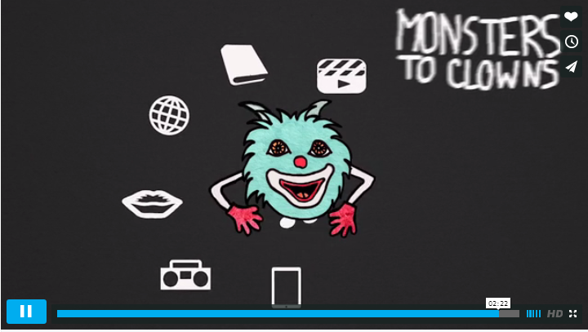
[Monsters to Clowns, official trailer http://vimeo.com/96921359 ]

Another Estonian project is connected with children as well: Above serial, in which the main character – Lucas and the group of indygo children, are struggling against the increasing phenomenon of technology dependence.
The Reward is a Danish animated film produced by Sun Creature Studio, which has gathered more than 15,000 users and over one million displays. Will it gain comparable recognition during the Filmteractive Market as well?
A co-production of American, Swiss, British, Swedish and Polish authors called Axion, is certainly visionary and comprehensive project with firmly declared scientific rigor. This interactive document is based on the mobile application, and it is described as ‘visual poetry combined with scientific concept, as a result of which the desire to discover becomes almost a sensual experience’.
Sweet Dreams is an interactive movie directed by the Polish team InventCore, which allows users to influence the course of action.
It is also worth paying attention to the two Italian projects. Komplex – uses augmented reality to present dark and dystopian story, and The Debtor – depicts corruption in the form of online series. Both productions have already been honored with international awards in the following categories: interactive TV project and branded entertainment.
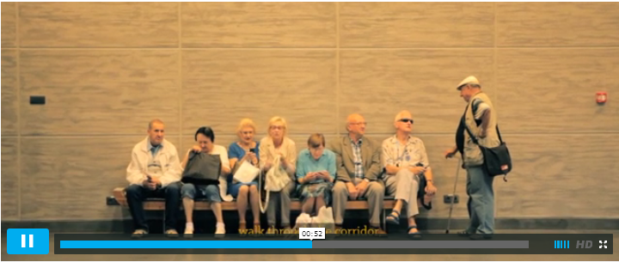
[ ZAMEK, trailer http://vimeo.com/82503069 ]

The record of finalists also includes the most productively advanced Polish project Castle, in which interactive fiction is combined with history and documentary notions. This conception has been created not only due to an impressive amount of materials, which consider more than just movies, but also with respect to enormous engagement and commitment of over 200 people involved in the project.
On the 25th of September, these eight projects will compete for the grand prize of the Filmteractive Market. Congratulations and see you in Lodz Film School:
http://filmteractive.eu/programme.php

Tickets are available at: http://filmteractive.eu/tickets.php

