25.09.2014
Filmteractive Market 2014 – meet the winners
Filmteractive Market is an unique event which had its second edition this year. It gives creators from all over the world an opportunity to present their innovative films, crossmedia and digital content projects. Furthermore, during the event creators may meet their potential clients, companies, brands and marketers interested in buying a project or a technological solution. However, the most important goal of Filmteractive Market is finding talented people and supporting them, as well as allowing them to show their ideas to the public and achieve a financial success.
This year Filmteractive Market main prize sponsored by EVIO Polska won creators of a Danish project The Reward. Additionally the jury rewarded a Polish-Swedish team which presented a project Axion. This international collaboration resulted in winning a special award for the best project coming from the Baltic Sea Region founded by The Northern Dimension Partnership on Culture (NDPC).
All the projects were evaluated in two stages by the international expert panel which included Pietro Pierangeli (Subvertising, Italy), Charlotte Appelgren (Cine-Regio, Denmark), Maciej Hazubski (IQ Partners S.A., Poland), Aurelie Taguet (France Télévision, France), Lucia Haslauer (ZDF, Germany), Sebastian Grabowski (Orange Labs, Poland), Andres Jõesaar (The Group of European Audience Researchers, Estonia), Martin Šimka (Evio Polska Sp. z o.o., Poland). The Head of 2014 expert panel was Adipat Virdi, trans media producer from the UK.
In the first stage of evaluation the jury selected 8 best projects from all submitted applications, which were later presented during Filmteractive Market. In the second stage, the experts could ask projects’ creators further questions what allowed them to choose main winners of the whole competition.
- A record number of over 70 interactive projects was submitted to this year’s Filmteractive Market. Their authors come from all over the world, for instance India, Europe and United States – reveal Agata Lepianka, Project Manager Filmteractive. – It shows clearly that Filmteractive Market as well as projects presented during the event have a huge potential. We keep our fingers crossed for all participants. Moreover Filmteractive Market is for them an extraordinary chance to hear the best international experts’ opinions on their works. The level of this year’s submitted applications was remarkable, and therefore I suppose congratulations to all Filmteractive Market 2014 winners are in order!

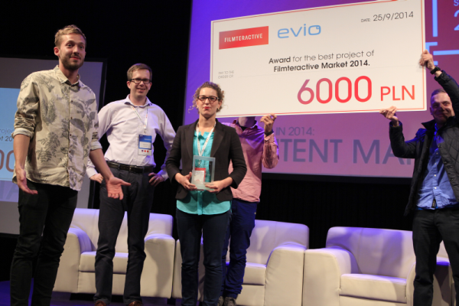
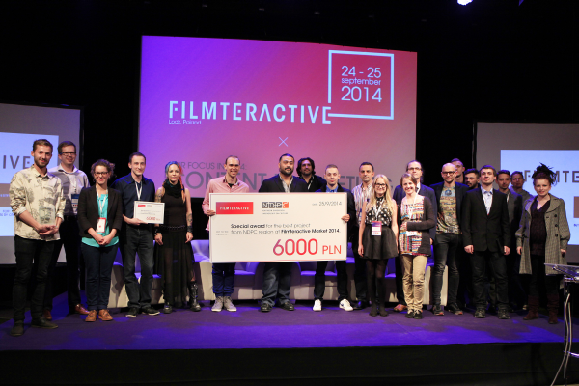
Find more on: http://filmteractive.eu
https://www.youtube.com/user/Filmteractive
https://www.facebook.com/FilmteractiveFestival
https://twitter.com/Filmteractive
https://www.linkedin.com/company/filmteractive

